Laser Locking

Rosalyn Chan

York University

PHYS4160

Cody Storry

30th November 2021

**Introduction**

The Laser Locking experiment describes the principles of process control using a PID loop. The origin of the error signal used in locking the laser is identified with the explanation of the lock-in amplifier whereby the performance of a laser lock is examined.

**Results:**

**Section 7.3.3: Set-up the Lock-in Amplifier**

Fast modulation is set up for the lock-in by setting the frequency range to 2, frequency control to 5, amplitude to 9 and course phase to 2. Four traces of the locking output and the modulation signal with position setting of 1,2,3 and 4 on the course phase adjustment is compared.

|  |  |
| --- | --- |
| Course Phase setting | Trace of locking output and modulation signal |
| 1 |  |
| 2 |  |
| 3 |  |
| 4 |  |

Table 1: Four traces of the locking output and the modulation signal with position setting of 1,2,3 and 4 on the course phase adjustment

The oscilloscope traces shown is the lock-in output. The lock-in output is the DC voltage that we get when the mixer and the low pass filter are used to combine the sinusoidal fast modulation signal (the reference signal) with the photodiode signal. The DC voltage out of that process is obtain when the laser is parked at a single frequency. From the table above, it can be seen that there were no changes to the traces of the lock-in output. However, the input signal moves up vertically only very slightly when the position settings is increased from 1 to 4.

**Section 7.3.5: Integrity of the lock**

**Exercise 1:**

Series of traces with different values of P, I, D and gain are recorded after successfully locking the laser.

|  |  |
| --- | --- |
| Lock-in laser |  |
| P value at 10 |  |
| I value at 10 |  |
| D value at 10 |  |
| Gain setting at 10 |  |

Table 2: Series of traces when values of P, I, D and gain is set to 10.

Values of P, I, D and gain are changed after the laser is successfully locked. From table 2, it is observed that only values set to 10 for P, I, D and gain changed while the rest of the values remained the same as the lock-in laser. As each setting were changed to observed any effect it had once the lock is engaged, it is seen that the signal moves higher up for P, I and D from the position of the locked in laser but the highest when the gain is changed. Therefore, apart from any values set to 10 for P, I, D and gain, the laser is perfectly lock but at values set to 10, the laser jumped out of the locked state.

**Exercise 2:**

With the PID regulator switched off, the slow modulation is increased to 2. The magnitude of the frequency modulation associated with amplitude 2 is 5.151× ${10}^{9}$ Hz.

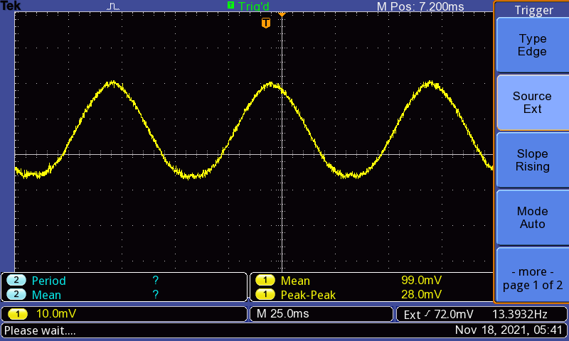

Figure 1: Photodiode signal at amplitude setting 2

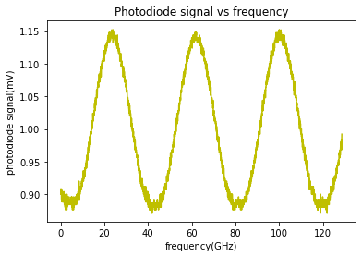

Figure 2: Plot of photodiode amplitude to frequency.

The noise is caused by the laser frequency jumping around the centre of the absorption peak due to environmental perturbations and lock-in feedback. This noise has a standard deviation and the laser’s frequency spends about 70% of its time in a band of frequencies with edges ± of the standard deviation away from the centre of the peak.

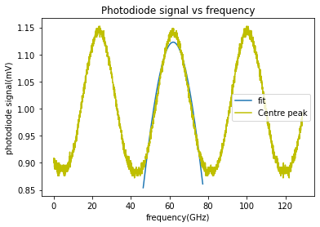

Figure 3: Gaussian fit for the middle peak.

The standard deviation of the oscilloscope trace of the locked laser is found to be (0.0046±0.0007) mV in python. For the conversion of the standard deviation in mV to the frequency units, the x-axis data of the full absorption peak is converted to frequency as seen in figure 2. Next, assuming the gaussian absorption peak is inverted as usual, the point on that gaussian that is the standard deviation value of the lock-in laser in mV is found above the point with minimum voltage at the gaussian’s centre. The distance on the x-axis from this point to the centre in frequency is the standard deviation of the laser’s frequency fluctuations, that is the half-range over which the frequency is fluctuating.

However, as can be seen from figure 2, the oscilloscope trace obtained did not managed to produce a gaussian absorption peak that is inverted. Therefore, the point on that gaussian were not able to be found to make a proper conversion of the standard deviation in mV to frequency. On the other hand, the standard deviation of the fit to the centre peak is found to be (21.01±0.08) GHz.

**Discussion:**

In conclusion, although the experiment was successfully performed with locking the laser, it was still deemed to be not a good lock. In theory, a perfect lock would be one where the lock-in output’s jitter is made entirely of just the fast modulation and no additional noise. This however was not the case as when the laser is locked, its frequency is jittering back and forth around the centre of the peak to which it is locked because the fast modulation is turned on and because of environmental effects and the lock-in feedback which causes its frequency to constantly drift away and get pushed back towards the centre of the peak. From table 2, it is seen that the laser jumped out of its locked state when each P, I, D and gain setting were set to 10 simultaneously. This indicates that the laser is poorly locked. One of the reasons might be because the laser’s feedback is just too damped, making it unable to keep up with rapid environment fluctuations.

**Appendix A**

Standard deviation and uncertainty of the gaussian fit.

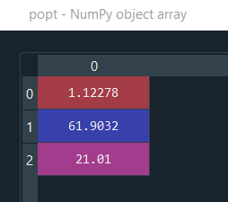

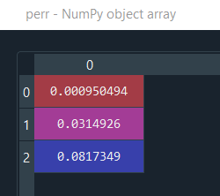

**Appendix B**

Standard deviation of the lock in laser

